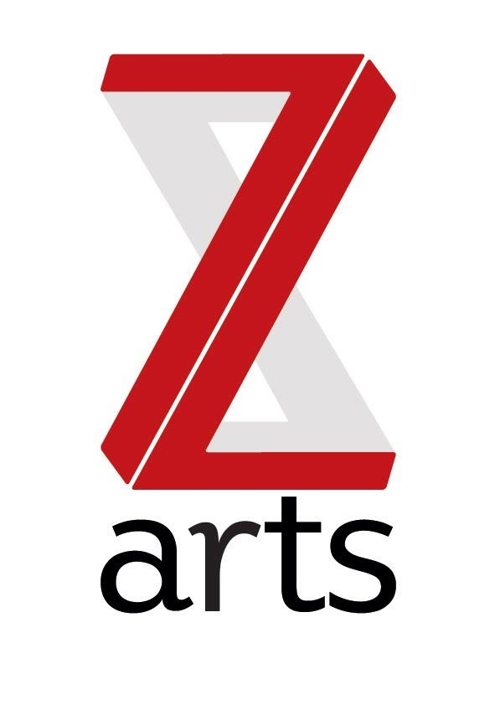

JOB DESCRIPTION

TITLE: Music & Community Studio Manager

RESPONSIBLE TO: Creative Development Manager

Z-arts is Manchester’s venue for children and families, delivering projects and activities in our large Edwardian building in Hulme, in schools and community settings, working locally, regionally and nationally. Last year over 20,000 people took part in a creative activity from Z-arts and 100,000 people came through the building. Dedicated to inspiring creativity, Z-arts delivers a broad range of visual and performing arts events, performances, exhibitions, activities, workshops and participatory opportunities.

PURPOSE: This is an exceptional opportunity to develop a career within the music industry based with an arts centre focused on working with children and young people. The Music & Community Studio Manager will help Z-arts to provide music education to address inclusion, equality and diversity for all young people in Greater Manchester. The Music & Community Studio Manager will have responsibility for our Levi’s Music Studio and Studio Z recording studio where they will create a culture of music making that harnesses potential and encourages all participants to build their skills and develop their talents.
The Music & Community Studio Manager will deliver high quality music activity across a wide range of genres in the Levi’s Music Studio. They will work to engage new audiences and help to increase the use of the studio through advertising, events and partnerships. They will need to be proficient in the use of our technical equipment, ideally have live music experience and knowledge to enable young people to access and record other forms of music making and support them to showcase their work and talent both live and digitally.
Working with Z-arts staff and partner organisations they will take the lead on developing and delivering music making activity throughout the organisation, delivering a high-quality service to young people, and our funders. They will manage our new Greater Manchester outreach programme ‘Band Of Boroughs’ and will be responsible for supporting freelancers across the city, liaising with partners and funders, delivering the project at Z-arts and ensuring the smooth running of the programme.
Additionally, they will take the lead on all monitoring and evaluation aspects of the programmes to ensure Z-arts are making a difference and meeting all stakeholder requirements.
HOURS: The hours of the role are 30 per week but the requirements of the business are such that a high degree of flexibility is necessary and frequent evening and weekend work will be a required as part of your rota.

SALARY
£16k for 30hrs per week (£20k pro-rata)

MAIN AREAS OF RESPONSIBILITY:

Engagement
- To take the lead for the Levi’s music project programme; to mentor young people (primary to adults) & emerging artists and develop training programme for individuals, community and education groups to develop their skills in creativity and music-making.

- To devise and deliver workshops & support masterclasses & deliver our regular drop in evening sessions supporting your people on music creation and artist development.

- To encourage participants to become volunteer ambassadors and support the programme delivery, passing on the skills they have learnt to others through peer learning.

- To collaborate with other Levi’s music projects (Birmingham, Liverpool & London) to share good practice and maximise outcomes for all organisations and Levi’s.

- To create an open-access music hub where young people, emerging artists and the local community learn how to make music and use new technology.

- Support participants to access music, arts and cultural sectors and where appropriate signpost to employment, education and training within these sectors.

- Expand on our outreach strategy to engage more young people, emerging artists and education & community groups to increase use of the studio. E.g. schools, partner organisations, community groups.

Studio Management

- To oversee and be responsible for the day-to-day management of the music studio including managing bookings, maintenance, security and overseeing health & safety including ensuring we are operating with covid-safe procedures.

- To be responsible for the day-to-day management of the music studio ensuring all users are able to access the creation and recording of music whatever their ability.

- Ensure that examples of music studio work is catalogued, archived and broadcast though appropriate channels and networks helping young musicians at Z-arts to appreciate the cultural value and significance of their music and to document, preserve, share and archive their work.

Z-arts

- To be the technical lead for Z-arts music activity, by providing help and guidance to participants and staff on: Preparing and setting up for shows and events including basic live sound engineering, overseeing and assisting music recording sessions and studio sound engineering.

- Support music events and projects across Z-arts where required to ensure there is cohesive strategy for the music programme across the organization.

- Support music events within the Z-arts programme by providing sound tech support.

- Liaise with funder and other collaborators/partners to share learning and disseminate best practice.

- To be responsible for budget management, financial record keeping and statistical data collection as appropriate and in accordance with GDPR and funder guidelines.

- Monitor, measure and evaluate the programme through data, highlighting progress outcomes and any risks. Actively encouraging youth led evaluation through blogging and vlogging and other creative means to record and document things that matter to participants.

- Deliver and administer accreditation that recognizes skills development in: technical skills, functional skills, social skills and communication skills.

General
- To act as a Duty Manager and IRT (Incident Response Team) member as and when required.
- To work with the board and entire staff team to support and deliver Z-arts strategic and creative vision.
- To understand, actively promote and adhere to Health & Safety legislation and Z-arts’ Health and Safety policy.
- To adhere to all Z-arts policies and procedures.
- Any other duties required by the Senior Management Team

Essential Skills
- Experience of working with young people, artists and community
- A proven track record of developing key partnerships
- Ability to develop new partnerships and realise new opportunities
- Experience of project & budget management
- Experience of writing and implementing effective action plans
- Experience of organising events
- Experience and understanding of sound recording, editing and music production within the Apple system and using Logic & Ableton
- Understanding of a wide range of digital music equipment including knowledge of using and set up of DJ equipment
- Experience and understanding of mixing and post-production, including mastering
Desirable:
- Experience writing funding applications and developing new initiative projects
- Experience and understanding of creating and producing podcasts, blogs and vlogs.
- Experience of working with information systems, databases and websites
- Knowledge of the music, arts and cultural scene in Greater Manchester
- Degree or equivalent qualification in music related subject
- Experience of working with educational institutions
Person Skills
- Excellent interpersonal skills and ability to work within a diverse team
- Excellent communication skills, both verbal and written
- Ability to build and sustain good working relationships
- Ability to exercise initiative and take personal responsibility
- Excellent organisational skills
- Strong time management skills
- Attention to detail

To comply with legislation covering the activities at Z-arts, it is required that all staff undertake training as directed by their line manager. It is also essential that all staff carry out their duties in a safe manner in accordance with the current Health and Safety at Work legislation.

