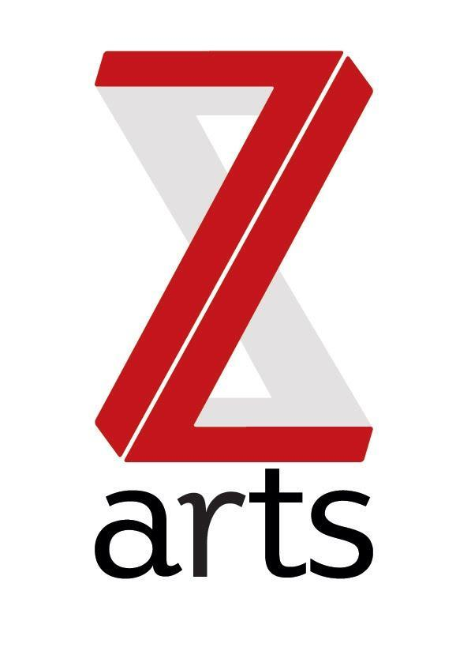

JOB DESCRIPTION

TITLE: Manchester Cultural Education Partnership (MCEP) Coordinator

RESPONSIBLE TO: Chief Executive, Z-arts

BACKGROUND:

Manchester Cultural Education Partnership is a network of cultural organisations, schools, children and young people and others in the city collaborating to ensure that the city will become a beacon of cultural and creative excellence for children, young people and their families, where culture and creativity is truly valued and opportunities are varied and easy to access, so everybody can take part. Children and young people in Manchester will have the creative ability to flourish.

The network reports to and is supported by a Strategic Board of senior representatives. Both the board and network draws membership from education, culture, youth and play (community and voluntary sector), business and the Local Authority.

MCEP is committed to and pro-active in making sure that children, young people and their families have an authentic voice and roles in shaping and leading Manchester’s Cultural Education Partnership.

As one of the lead partners for MCEP Z-arts will host and manage this post. Z-arts is Manchester’s venue for children and families, delivering projects and activities in our large Edwardian building in Hulme, in schools and community settings, working locally, regionally and nationally. Last year over 4,000 people took part in 20,000 creative engagements and 89,565 people came through the building.

PURPOSE:

To provide administrative and project management assistance to the Manchester Cultural Education Partnership, coordinating communication and organisation across the network members, including supporting the project management of initiatives, administrating meetings for the Strategic Board and Task Groups and working with the Chief Executive of Z-arts and a core group of network members to support the governance and development of the Partnership.

SALARY: £19,000 PRO RATA

HOURS The hours of the role are hours 14 hours per week

DURATION: Twelve-month contract.

MAIN AREAS OF RESPONSIBILITY:

Administration:

- Convene and service MCEP Board and Working Group network meetings.

- Convene any task groups drawn from the network to progress development, projects and initiatives in relation to priority areas of delivery and supporting the lead individuals for task groups to service meetings.

- Support the Working Group Chair to prepare reports, plans, presentations or to progress actions on behalf of MCEP.

- Maintain stakeholder database to a high standard.

Project Management:

- To increase the profile and membership of MCEP by supporting the development of communication materials, event planning and delivery, representation of the Partnership at information ‘market stall’ events and forums/other networks.

- To support Task Groups drawn from the network membership to deliver projects and initiatives. This will include managing several project timelines, project reporting, including delivery risk analysis, undertaking best practice and funding opportunities research, coordinating communication with external partners and contributing to funding applications.

- To increase engagement from across a variety of sectors, ensuring an appropriate representation from each. This will include improving and increasing communication across the network’s membership, in particular by coordinating key messages, updates and opportunities for schools, further and higher education, youth and play, cultural organisations, business partners and funders. This will include face to face, as well as written and e communication.

Organisational:
- To understand, actively promote and adhere to Health & Safety legislation and Z-arts Health and Safety policy.

PERSON SPECIFICATION:
Excellent demonstrable skills in Microsoft Office and Excel
Excellent demonstrable skills in managing projects
Strong organisational and time management skills
Ability to demonstrate attention to detail
Excellent interpersonal skills and ability to work within a diverse team, including children, young people and members of the public.
Excellent communication skills, both verbal and written
Ability to build and sustain good working relationships
Ability to exercise initiative and take personal responsibility
A fast learner
Interest in working in a creative environment.

