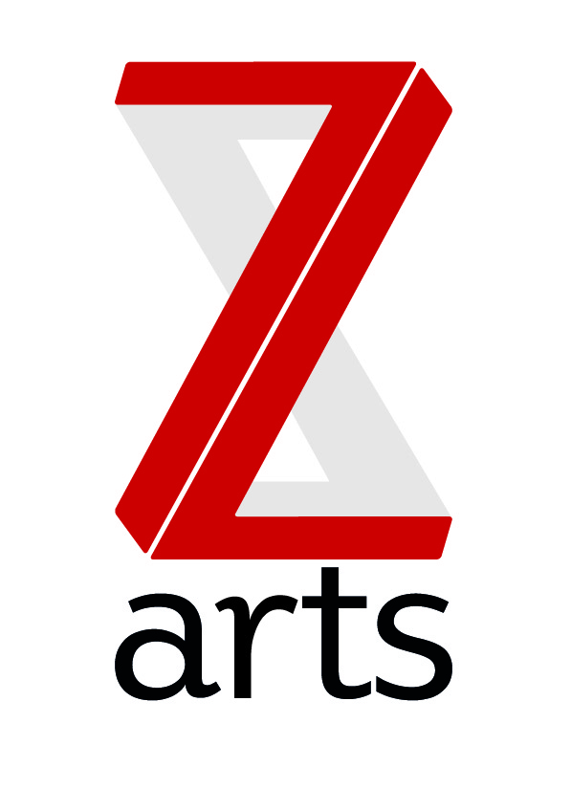
JOB DESCRIPTION-

TITLE: Music Leader

RESPONSIBLE TO: Youth Music coordinator

Salary: £37.50 per session

Z-arts is a multi-art form venue with a mission to inspire and enable generations of young people from across Manchester and beyond to use their creativity to maximize their potential. As one of the most versatile cultural buildings in Greater Manchester, Z-arts has facilitated and developed a broad range of visual and performing arts events, activities and workshops, exhibitions and participatory opportunities.

PURPOSE:
To deliver a series of weekly after school music classes as part of our Youth Music funded, Allsorts Essential’s Programme.
HOURS:
- Every Tuesday
- Term time only
- Starting Tuesday 13th September 2016
- Ending Tuesday 13th December with the option to renew contract
- 1 hour session, 4pm – 5pm, (arriving 15 minutes early to set up, and leaving time to pack away)
MAIN AREAS OF RESPONSIBILTY:
- Make any necessary plans and preparations for each session.
- To deliver music classes to young people aged 6-10 years old, incorporating use of instruments (provided by Z-arts), song writing and singing.
- To lead and facilitate high quality music activities in each session, taking into account the individual needs of the children.
- Support Z-arts in delivering music activities based around the themes/topics that Z-arts have in place for each term.
- To work closely and communicate with the Youth Music Coordinator to ensure the smooth running of the project.
- To ensure that participants and new comers are warmly welcomed to the sessions, treated with respect, listened to and fully supported in their learning and creative development.
- To provide support and information to encourage participants to continue music making or leaning at home or throughout the school holidays.
- To monitor the progress of the project.
- To fully understand the programme objectives and expected outcomes.
- Make all necessary arrangement to ensure you have the equipment and other resources you need.
- To ensure all safeguarding requirements are met.

PERSON SPECIFICATION
  - Experience of working with young people.
  - Experience of teaching music to all abilities.
  - Experience of delivering work that engages with young people from a diverse range of communities.
  - Relatable and be able to connect with young people from a diverse range of communities and differing abilities.
  - Experience of delivering music classes/workshops/sessions in community settings.
  - Able to demonstrate strong organisational skills.
  - Able to demonstrate strong communication and interpersonal skills, both verbal and written.
  - Self-motivated and enthusiastic about your work.
  - Ability to work on own initiative.
  - Have a good track record for attendance and time keeping.

PROJECT DESCRIPTION

Allsorts ‘Essentials’ is aimed at Key Stage 2 with a group of up to 15 young –musicians that work on introductory music-making. The sessions take place afterschool for one hour per week over 53 weeks, targeting those with no experience of music-making.

The project includes:
- Singing and playing a range of worldly instruments.
- Playing and performing as individuals and in groups.
- Improvise and compose music, write songs and lyrics.
- Learn musical notations and put to use.
- Learn about the world of music.
- Listen and appreciate music from different traditions.
- Work towards Bronze Arts Award.

‘Essentials’ uses the following themes as inspiration. Using these themes puts the young people at the centre of the creative process and will also help them to think about their current situation, and the challenges they may face, and hopefully help them to realise that they can influence what happens in their lives now and what their future can be.
- My Life (May – July 2016) Who am I? Who are my family? What do I like/dislike? What would I change? How would I change it? What does success/happiness look like?
• My Place (September - December 2016) Where do I live? Who are my community? What can I do to improve my place? Where do I want to be? How do I get there?
• My Voice (January - March 2017) What do I currently say? How do I project myself? Is this what I want people to hear/see? How can I make myself heard? What do I want to say?
• My Future (April – June 2017) What does my Utopia look like? What do I want to achieve? How do I achieve this? Who can help me? How can I help myself?
• Reflection (July 2017) What have I learnt? How can I apply to my life? How have I grown?

