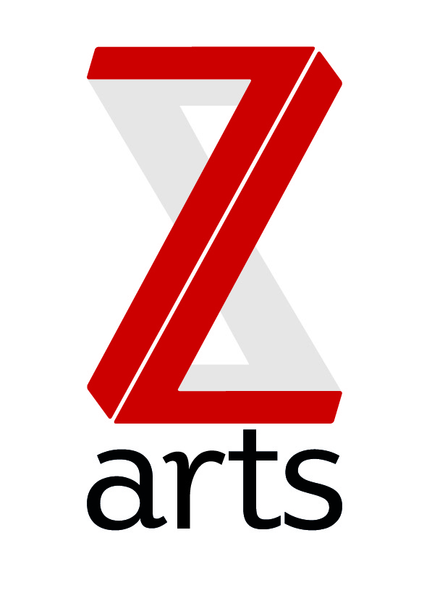
Z-arts Marketing Volunteers
This is a unique way to gain hands on experience in a vibrant creative arts venue, by carrying out planned and supervised work that enables you to:
- Gain experience in arts administration through website updates, event promotion and liaising with artists.
- Work alongside the Marketing Manager and Front of House team and learn how to effectively plan, prepare and coordinate events
- Experience working hands-on in a fast moving environment

We’re looking for a volunteer who can commit 1 day per week to help with marketing and audience development.

This is an example of some of the work that a marketing volunteer would be involved in.

Main Areas of Responsibilities:
- Google analytics tracking
- Overprinting flyers and posters
- Designing new season promotional content for mac’s
- Updating the social media profiles: Twitter, Facebook, YouTube, Instagram etc.

Person Specification:
- Excellent verbal, written and communication skills.
- A working knowledge of social networking and the ability to communicate effectively through social media.
- Willing to use own initiative.

How to Apply:
To apply for this placement, please email Laura Stevens, Marketing & Audience Development Manager with:
- an up to date CV
- a covering letter (one side of A4)*
- two referees
*Your covering letter should include information about why you feel you are suitable for this placement, what you hope to learn, and an outline of any approaches or ideas you would use.

Deadline: Ongoing
Contact: laura@z-arts.org

