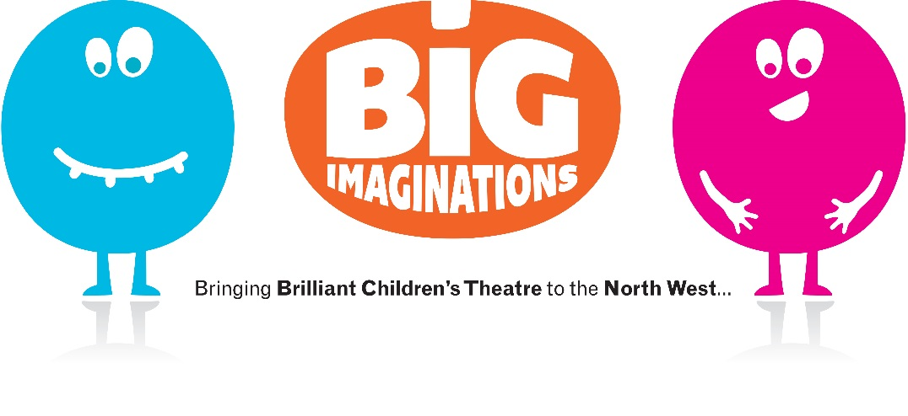
Big Imaginations
Call-out for theatre makers to create
a show for 8-13 year olds in 2017.

Background
Big Imaginations is a network of 15 venues and programmers from across the North West who share a commitment to bringing brilliant children’s theatre to the region. As well as supporting existing touring theatre, we are funded by Arts Council England’s Strategic Touring to commission three new pieces of work for touring; two early years pieces, and the third being a piece for 8-13 year olds, to be mounted in 2017.

The Big Imaginations partners are:
Z-arts (lead partner); The Atkinson, Southport; The Boo, Rossendale; the Brindley, Runcorn; Burnley Arts Centre; Cheshire Rural Touring Network; The Citadel, St Helens; The Edge, Chorlton, Manchester; LICA, Lancaster; Sale, Waterside Arts Centre; Spot On Rural Touring Network; Unity Theatre, Liverpool; Whitby Hall, Ellesmere Port; Wigan MBC; Wild Rumpus (Just So Festival).

We want to be bold and experimental in our commission choices. We want to commission work that celebrates diversity, and which builds diverse audiences by allowing them to see themselves reflected on the stage; work that pushes boundaries in terms of form in order to ensure that our programming does not become safe and uninspiring. This commission is about celebrating the talent we have in the North so that we continue to help develop the quality of work available on our doorstep.

We are looking for any kind of theatre maker and are actively seeking BAME artists and applicants: Writer; director; performer; company; artist; designer etc.

Criteria
- The piece has to be targeted at 8 – 13 year olds.
- We are committed to representing the diverse world we live in. Your proposal must respond to ACE Creative Case for Diversity
http://www.artscouncil.org.uk/what-we-do/our-priorities-2011-15/diversity-and-creative-case/.

- We are committed to supporting artists from the North
- This commission will need to begin with an outreach phase, targeted to reach 8-13 year olds, as part of the r&d in 2016, acting as a taster to entice audiences in this age range to attend the final piece of theatre, having played a part in its development.
- The piece must have the ability to be performed across the network, so ideally it needs to be adaptable for anything from rural touring to mid-scale venues and schools.

Timeframe
- Deadline: 11th March 5pm
- Interviews: End March 2016
- Outreach and R&D: Autumn 2016
- Creation & rehearsals: 2017
- Opening 2017 (to suit artists and partners)
- Touring 2017/18

Budget
- We are working with an initial draft production budget of £65,000 (excluding tour costs), confirmed via ACE Strategic Touring and funds from Z-arts and other Big Imaginations members. We are seeking additional funds from co-commissioners around the country to increase this total as well as adding touring venues.
- Partners are also contributing significant in-kind resources including space, marketing, mentoring, working outdoors or in rural locations, tour booking, engaging with schools and communities, outreach with low engagement communities.
- The co-commissions will also be developed in partnership with venues and promoters outside of the network, further strengthening collaboration, sharing good practice and widening reach.

How to apply
- Submit one side of A4 paper summarising your idea, including any other artists you may wish to work with, if known.
- Attach a copy of your cv / biography (for each collaborator if the application is from more than one person)
- Supply a link to your website or other examples of previous work
- Submit a separate page of A4 in which you address:
- How you will incorporate the Creative Case
- How you will support the development of Northern artists
- Ideas you have for the outreach element and who would deliver it.

Send your completed applications to liz@z-arts.org by 5pm on Friday 11th March 2016.
Further information
Any questions, please contact Liz Z-arts on 0161 226 1912 or email liz@z-arts.org

